2015

Volunteer Training Manual

Table of Contents
Welcome to Horseshoes of Hope Equine Academy ………………………………… 2
Who We Are …………………………………………………………………………………………. 3
What We Do …………………………………………………………………………………………. 4
Barn/Arena Rules ………………………………………………………………………………….. 5
Volunteer Roles …………………………………………………………………………………….. 6
Volunteer Rules and Regulations ………………………………………………………….. 10
Horse Leader Competencies ………………………………………………………………… 11
Side-walker Competencies ……………………………………………………………………. 14
Disability Awareness …………………………………………………………………………… 15
Emergency Procedures ……………………………………………………………….……….. 17
Contact Information ……………………………………………………………………………. 20

Welcome to Horseshoes of Hope Equine Academy

Greetings!
Thank you for choosing to volunteer with Horseshoes of Hope Equine Academy! Whether you’ve been surrounded by horses for years, or will be working with them for the first time, we are excited that you will be joining us as we provide Equine-Assisted Activities and Therapies (EAAT) to the central Indiana community.
We hope that you not only grow to love the riders and horses that make the program so unique, but that you also have the opportunity to learn yourself, whether that’s developing horsemanship skills for the first time or learning what a difference therapeutic riding can truly make in an individual’s life.
Since its inception in early 2010, Horseshoes of Hope has provided thousands of children with the opportunity to experience the wonderful benefits of interacting with horses. Our programs have taught us how truly essential the services we provide are and also how important volunteers can be to developing a strong and sustainable program.
Moving forward, we ask that you take the time to read through the volunteer manual we have provided to prepare you for a Horseshoes of Hope Volunteer Training session. The background provided here will only better prepare you to participate in the training session, and have a firm grasp on what Horseshoes of Hope is all about.
Please feel free to contact us if you have any questions along the way.
Thank you,
Horseshoes of Hope Equine Academy

Who We Are
Established in 2010, Horseshoes of Hope Equine Academy enhances the lives of children and adults with disabilities or chronic illness through the use of a variety of Equine-Assisted Activity programs such as Therapeutic Riding, Equine Facilitated Learning, Hippotherapy, and Equine Facilitated Psychotherapy. Our environment provides a refreshing departure from conventional clinical treatment facilities, where participants benefit from facilities designed in compliance with ADA and PATH International established requirements and standards.

Equine Assisted Activities have been shown to improve self-control, increase risk-taking capacity, encourage teamwork, and bolster confidence and self-esteem. Individuals with physical disabilities benefit primarily through the movements of the horse, which strengthen and support the natural motion of the spine and pelvis. Riding also builds and tones muscles; improves flexibility, balance, and coordination; and fosters greater freedom of movement. Those with cognitive or learning impairments can improve their attention span, communication and language skills, and concentration and memory.

Our equine program currently serves individuals affected by Autism, Down Syndrome, Muscular Dystrophy, Multiple Sclerosis, Sickle Cell Anemia, Spina Bifida, Cerebral Palsy, developmental disabilities, sensory disorders, and many other conditions. In addition, our Horses for Heroes program is a unique opportunity for Veterans and their families from surrounding counties to participate in Equine Assisted Activity programs.

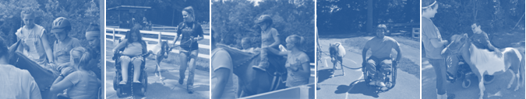

What We Do

Horseshoes of Hope Equine Academy is dedicated to providing a variety of Equine-Assisted Activity and Therapy (EAAT) programs for both children and adults with disabilities and chronic illness. Information regarding all of our current programs can be found below:

Therapeutic Riding
Taught by instructors who are certified by the Professional Association of Professional Horsemanship (PATH), Therapeutic Riding lessons are designed for children and adults with physical, cognitive, psychological, and developmental impairments, and are intended to improve the overall quality of life of the rider. Each lesson is designed to meet the individual needs and goals of each rider based on an initial assessment of each client's skills and abilities. Our specially trained horses and volunteers ensure that each rider has a unique opportunity to reach their potential in a safe environment.

Equine Facilitated Learning
Designed to meet the individual needs of each group, Equine Facilitated Learning activities provide a unique opportunity to develop skills outside of the classroom setting in a fun and exciting environment. Programs can be designed to fulfill state educational standards, meet basic badge requirements for scouts, or can be developed to meet your unique needs!

Leadership Development
Interested in adding a unique twist to your next corporate or group retreat? Horseshoes of Hope provides innovative programming to help our clients realize their true potential. Sessions related to leadership development, communication skills, and teamwork can all be scheduled to help propel your organization to the next level.

Rough Riders Program
Directed towards Veterans and their families of any age who have been diagnosed with PTSD, TBI, Physical Injuries, various Emotional and Psychological Challenges, or are affected by homelessness, our equine-assisted activity and therapy programs are tailored to address specific issues faced by military personnel. To accomplish this mission, Horseshoes of Hope connects with Department of Veterans Affairs Medical Centers and Clinics, as well as individual veterans to provide this unique opportunity.

Barn/Arena Rules
Horseshoes of Hope Equine Academy is dedicated to ensuring the safety of the riders, volunteers, staff, and horses that make the program so unique. In order to ensure that all individuals remain safe while on the property the following rules have been developed:

- Walk at all times
- Wear proper clothing
- Follow guidelines/policies as outlined in the HoH Volunteer Manual and at the HoH Volunteer Training
- No smoking, alcohol, drugs, or weapons on the premises
- Listen and follow directions given by staff members
- No throwing things in or around the barn/arena
- Do not feed the horses unless given permission by staff
- Do not enter stalls/pastures/paddocks without permission from staff

Volunteer Roles
Individuals interested in volunteering with Horseshoes of Hope Equine Academy have the opportunity to participate in a variety of opportunities both in and around the facility. The following opportunities currently exist for interested volunteers:

Programmatic Volunteers

Basic Requirements
A programmatic volunteer must...
- Be 18 years of age
- Submit an annual volunteer profile and liability waiver form
- Attend a volunteer training session
- Agree to a specific shift/s for the duration of the session
- Be physically/emotionally fit to meet the demands of the
program

Horse Leaders
Horse Leaders are responsible for leading and handling the horse during the therapeutic riding or hippotherapy lesson, and should be knowledgeable of their role in a typical lesson format and in various emergency situations. The leader is also responsible for grooming and tacking their respective horse prior to daily lessons.

- Should have strong horse knowledge related to horse behavior and psychology
- Should be able to independently groom and tack the assigned horse
- Should be able to maintain control of the horse through a variety of obstacles, gaits, mounting, and dismounting procedures.

Side-walkers
Side-walkers are responsible for assisting the rider physically, cognitively, and emotionally as necessary throughout the duration of the therapeutic riding lesson. They are encouraged to interact with the participant to reinforce the instructions and praise of the instructor, while respecting the instructor’s need to communicate efficiently with the rider.
- Should be knowledgeable of the different types of side-walking holds and be able to perform each independently.
- Should be comfortable interacting with the participants throughout program session.
- Should be physically capable to participate for the entire duration of the lesson.

Stable Managers
Stable Managers are specially designated volunteers who have extensive experience working as a horse leader and side-walker, and who often have extensive horse experience. Stable Managers are responsible for ensuring that horses are groomed, tacked properly, and in the arena on time for the scheduled lesson, as well as maintaining order and cleanliness in the barn during schedule lesson times.
- Should have strong horse knowledge related to horse behavior and psychology
- Should be able to independently groom and tack any assigned horse
- Should be knowledgeable of all organization policies and procedures

Group Program Assistants
Group Program Assistants provide support for the Horseshoes of
Hope staff when facilitating a variety of Equine Assisted Activity
Programs for large groups.
They are responsible for interacting with program participants to help
them achieve the goals designated by the program, as well as provide
assistance related to basic program design, set up, and clean up.
- Should feel confident in their ability to interact with large groups of clients.
- Should be knowledgeable of all organization policies and procedures.

Facility Volunteers

Basic Requirements
Facility and Administrative volunteers must...
- Be 14 years of age, or accompanied by an adult
- Submit an annual volunteer profile and liability waiver form

Landscaping design/upkeep
Landscaping Volunteers provide Horseshoes of Hope with assistance in maintaining and designing the gardens surrounding the barn and arena area. Special projects may be provided to groups or individuals at the discretion of the staff and may include pulling weeds, planting flowers, or watering plots.

Pasture Maintenance
Pasture Maintenance Volunteers assist in maintaining the current pastures by removing excess brush, building/moving fences, and cleaning stock tanks when necessary.

Barn Upgrades/Repairs
Barn Maintenance Volunteers assist in maintaining the barn and arena areas throughout the year. Special projects may be provided to groups or individuals at the discretion of the staff and may include routine repairs, small and large scale construction projects, and general upkeep.

Administrative Volunteers

Basic Requirements
Facility and Administrative volunteers must...
- Be 14 years of age, or accompanied by an adult
- Submit an annual volunteer profile and liability waiver form

Marketing Design/Development
Marketing Volunteers provide assistance to the Horseshoes of Hope staff in developing marketing materials, revising the website, and updating all printed marketing materials. These volunteers help to shape the image of Horseshoes of Hope in the Indiana communities we serve.

Public Relations
Public Relations Volunteers assist Horseshoes of Hope to develop a relationship with the communities we serve. Specifically, they help by distributing marketing materials to local organizations, communicating with local businesses about current or potential partnerships, and provide support for all fundraising and riding events.

Fundraising
Fundraising Volunteers assist Horseshoes of Hope in planning and executing fundraising campaigns and events throughout the year to support rider scholarships, horse care, and facility upkeep. They assist in managing event committees and providing information to potential donors about the opportunities Horseshoes of Hope has available.

Event Planning
Event Planning Volunteers provide assistance in the planning and execution of special events hosted by Horseshoes of Hope. Responsibilities range from providing support during an actual event to developing concepts for future events and fundraisers.

Volunteer Rules and Regulations
Horseshoes of Hope volunteers are expected to abide by all barn and arena rules, but are also required to comply with the following:

Attire
- All volunteers must wear long pants and closed toed shoes at all times.
- Refrain from wearing expensive jewelry.
- Refrain from wearing jewelry that could easily be pulled off
(hoop earrings, long necklaces, etc…).
- Limit the use of perfume or cologne.
- Do not use your cell phone during lessons.

Scheduling
- All scheduling will be done through Susan Lambert via phone or text at 217-474-4872 or e-mail. (slambert@horseshoesofhope.com) prior to the start of each session. If you need to change your shift at any time please do not hesitate to contact us.
- If you need to cancel a shift in advance please contact Susan Lambert via phone or text at 217-474-4872 or e-mail at slambert@horseshoesofhope.com) 2 weeks in advance, or as far in advance as possible.
- If you have a last-minute emergency or are running late and cannot make it in time for your scheduled shift, please contact Susan Lambert at 217-474-4872 or John Lambert 317-442-1429. Please make sure you make contact with one of these individuals to make sure we receive your message. Both voice and text with both of the above numbers.
- In the event of a cancellation on our end, we will notify you as quickly as possible. Please ensure you have provided us with a number we can use to reach you at the last minute.

Horse Leader Competencies

Approaching a Horse______________________________________________________________________

- Approach the horse at the shoulder, or as near to the neck as possible, so that he/she can see you.
- Speak softly, or call the horse’s name as you approach to ensure the horse is not startled by your presence.
- Extend your hand and pat him/her on the shoulder or neck.

Note: Remember horses cannot see directly in front or behind them so consider their field of vision when approaching.

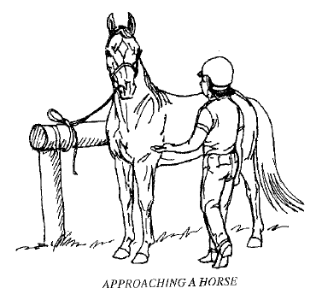

Catching a Horse____________________________________________________________________________

- To place the halter on the horse stand on the left side of the horse’s head, between the shoulders and head facing the same direction as the horse.
- Begin by sliding the nose band over the horse’s muzzle so that the nose band is on top and the chin strap is underneath his/her nose.
- Bring the crown piece (long strap) up over the horse’s head, right behind the ears, towards you and fasten appropriately.
Note: Speaking softly to or stroking the horse throughout the process will help keep the

horse calm and aware of its surroundings.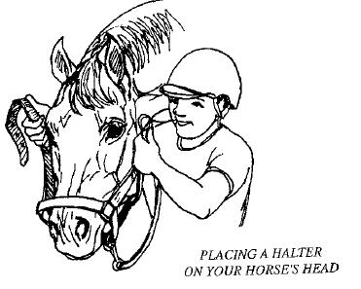

Leading a Horse____________________________________________________________________
- Lead the horse from the left side, maintaining position between the horse’s head and shoulder so the horse is not being pulled or tugged in any way.
- Hold the lead rope slack in the left hand and double the excess slack back until it is short enough to hold.
- Using the right hand, hold the lead rope 6-8 inches below the halter.
- When ready to walk, step forward and ask the horse to “walk on”
- If at any time the leader feels a need to pass another horse, the pass must be completed to the inside with complete communication between the leaders and riders involved.
Note: Proper safety procedures require that a space of a least one horse length be left between horses traveling in the same direction.
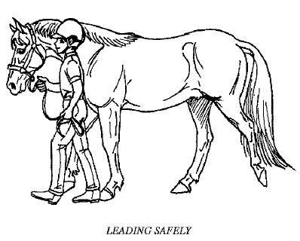

Turning a Horse_____________________________________________________________________________

- To turn away from the leader, move your hand underneath the horse’s chin to turn his/her head away from you.
- To turn towards the leader, ensure the horse remains an arm’s length away from you to avoid being stepped on, while gently guiding his chin inward.
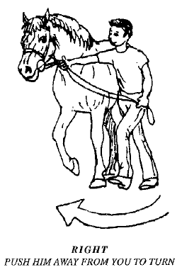

Tying a Horse________________________________________________________________________________

- Using a halter and lead rope (never a bridle and reins), begin the quick release knot level with the horses back or higher on a solid post or object.
- Ensure the length is appropriate for the intended activity—shorter for tacking purposes, longer for feeding—with a good standard of measurement being the distance the horse needs to touch his/her nose to the ground.
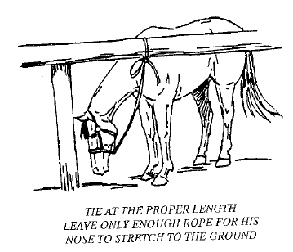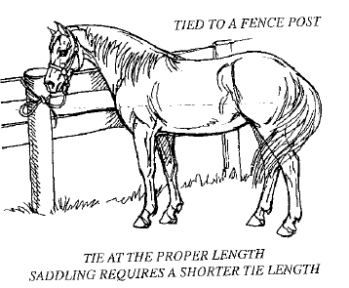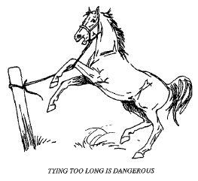

Note: Always use a quick release knot that can be pulled loose quickly if a horse should fight the rope or
be in danger.

Grooming a Horse__________________________________________________________________________

- Secure the horse using a halter and lead rope, with a quick release knot, prior to grooming.
- Start in the front and work your way back, ensuring that you maintain physical contact with the horse at all times.
- Use the following grooming tools in the following order:
- Curry comb: use in a circular motion to bring dirt to the surface. Should not be used on the face, legs, or bony areas of the horse.
- Hard/Dandy Brush: Uses short, firm strokes in the direction of the hair growth to remove dirt. Should not be used on the face or body areas.
- Soft Brush: Used in the direction of the hair growth to remove surface dirt.
- Mane/Tail comb: Used on the mane and tail to remove tangles starting at the bottom and moving upwards.
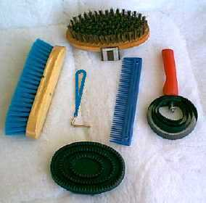
- Hoof pick: Used to remove dirt, rocks, and manure from the horses hooves.

Side-walker Competencies

Basic Responsibilities

- Side-walkers should remain at the horse’s girth, next to the rider’s leg, and should not walk further back near the horse’s flank.
- Side-walkers located on the same side as the horse leader will be designated as the “Lead” side-walker and will be responsible for performing an emergency dismount in the event that a certified instructor is unable to do so.
- Side-walkers are encouraged to reinforce instructions, provide appropriate praise, and encourage the rider throughout the lesson, but must not distract or interfere with the rider’s ability to listen to and communicate with the instructor.
- Allow the student the opportunity to process directions before intervening or reinforcing a command—too much stimulation may be overwhelming for some riders.

Types of Side-walking Holds______________________________________________________________

- Floating: The side-walker is responsible for walking besides the mounted rider and only providing support when needed. It is important that the Side-walkers remain in the proper position and do not drift backwards towards the horse’s flank.
- Ankle: The side-walker assists the rider by gentle holding the rider’s ankle and assisting with an maneuvers necessary that the individual cannot complete independently and/or to assist the rider in maintaining the correct position.
- Thigh-Hold: The side-walker will use the inside forearm to secure the rider, by placing it across the rider’s upper thigh gently, but refraining from placing excess pressure on the rider’s thigh.
- Back Support: The side-walker will use the inside forearm to support the rider’s trunk, by holding the appropriate strap on the rider’s harness, while the opposite arm is placed across the rider’s thigh for extra support.

Disability Awareness
The vision of Horseshoes of Hope is to be a leader in the development and implementation of Equine-Assisted Activities and Therapies which includes creating an environment that is not only safe and educational, but respectful of all individual participants. We encourage our volunteers to also adopt this mentality when interacting with HoH clients and other volunteers, and hope that the following will further explain the philosophies and beliefs that influence our client interactions.

Understanding Disability
We all experience disability at some point in our lives, through difficulties such as depression and insomnia, or physical issues such as vision loss or impairment. Disabilities may impair an individual physically, emotionally, mentally, or socially, and while it may play a role in shaping their lives, it is not a defining characteristic. People with disabilities can –and do- participate in all aspects of life.

Person First Language
Person-first language recognizes that someone is a person, or a human being first, and that the disability is a part, but not all of them. By using Inaccurate or inappropriate descriptors negative stereotypes and attitudinal barriers may be created limiting the potential of an individual, thus perpetuating an even greater need for the use of appropriate language.
Say:
The rider has a cognitive disability.
He has autism.
She uses a wheelchair.
He has Down syndrome.
He has a physical disability/quadriplegia.
She has a learning disability.

Don’t Say:
The mentally retarded rider.
He’s autistic.
She’s wheelchair bound
He’s Down’s.
He’s a quadriplegic.
She’s learning disabled.

Interaction
Individuals with disabilities do not want pity, nor do they want and recognition for coping with everyday life. They wish to be treated with respects and as equals with their peers who do not have disabilities. While even the most well-intentioned person may be uncomfortable, or self-conscious out of fear, it is important to remember that most people with disabilities want to promote understanding, so asking questions— when relative and within polite boundaries—if often acceptable. The following are some basic suggestions to consider when interacting with individuals with disabilities:

- Maintain eye contact.
- Don’t assume—just because an individual uses a wheelchair doesn’t mean they cannot walk.
- Talk directly to the person with the disability—even if using an interpreter.
- Ask if assistance is needed—don’t assume it is.
- If you do not understand what an individual has said, say so. Asking them to repeat the statement so you have a thorough understanding before answering will be appreciated.
- Use a normal tone of voice—raising your voice for those who have difficulty hearing may simply cause more confusion.
- When interacting with an individual using a wheelchair, never lean on or move the chair without the individual’s knowledge. The wheelchair is considered part of the body space of the individual who uses it.
- Be care not to assume that a person with one disability has others. An individual using a wheelchair may not also have a mental disability.
- When interacting with someone who has vision loss, always introduce yourself and all those around you who are present.
- When assisting an individual with vision loss or impairment offer your elbow for them to take as a guide. Do not grab the individual and physically maneuver them yourself.

Emergency Procedures
Emergency procedures have been develop to guarantee all volunteers and staff are aware of the proper response to a variety of situations to help ensure the safety of the rider and all individuals involved.

Emergency Dismounts______________________________________________________________
Instructors will advise when an emergency dismount is deemed necessary. In the event of an emergency dismount, please do the following:

Emergency Croup Dismount:
- Horse Leader: Halt the horse if at all possible
- Lead Side-walker (Left): Remove rider’s left foot from the stirrup
- Off-Side Side-walker (Right): Remove the rider’s right foot from the stirrup
- Lead Side-walker: Remove the reins from the rider’s grasp, place up on the horse’s neck
- Off-Side Side-walker (Right): Ask the rider to look towards you
- Instructor: Ask the rider to lean forward towards the horse’s neck
- Off-Side Side-walker (Right): Assist with passing the rider’s right leg over the horse’s croup
- Instructor: Bring the right leg over the horse’s croup
- Instructor: Slowly lower the rider down to their feet or to a seated position if necessary
Horse Leader: Turn the horse’s head towards the rider, pushing the hind end away from the rider, and lead the horse away.
- Horse Leader: Move the horse to a neutral location away from other riders and horses.
- Side-walkers: Stay with the rider until further direction is given by the instructor.
- Instructor: An incident report will be completed and submitted to the designated individual.

Emergency Crest Dismount:
- Horse Leader: Halt the horse if at all possible
- Lead Side-walker (Left): Remove rider’s left foot from the stirrup
- Off-Side Side-walker (Right): Remove the rider’s right foot from the stirrup
- Lead Side-walker: Remove the reins from the rider’s grasp, place up on the horse’s neck
- Instructor: Ask the rider to back towards the horse’s croup
- Off-Side Side-walker (Right): Assist with passing the rider’s right leg over the horse’s crest
- Instructor: Bring the right leg over the crest
- Instructor: Slowly lower the rider down to their feet or to a seated position if necessary
- Horse Leader: Turn the horse’s head towards the rider, pushing the hind end away from the rider, and lead the horse away.
- Horse Leader: Move the horse to a neutral location away from other riders and horses.
- Side-walkers: Stay with the rider until further direction is given by the instructor.
- Instructor: An incident report will be completed and submitted to the designated individual.
** If an instructor is unable to reach the rider in the event of an emergency dismount, the lead side-walker will assume the responsibility of safely dismounting the rider.

Other Emergency Procedures__________________________________________________

Loose Horse with a Rider
- All riding activity is stopped and all horses are halted
- All participants must remain silent as orders are given to the mounted rider by the instructor
- All other side-walker teams assume a thigh hold until further instruction is given
- The horse leader/side-walkers should wait for further instruction before approaching the horse

Loose Horse without a Rider
- All riding activity is stopped and all horses are halted
- All participants must remain silent as orders are given by the instructor
- All other side-walker teams assume a thigh hold until further instruction is given
- The horse leader and instructor will catch the loose horse

Rider Falls
- Horse Leader: Turn the horse’s head towards the rider, pushing the hind end away from the rider, and lead the horse away.
- Horse Leader: Move the horse to a neutral location away from other riders and horses.
- Side-walkers: Stay with the rider until further direction is given by the instructor.
- Instructor: Provides assessment of rider’s wellbeing and instructs side-walkers of what steps are needed (i.e. first aid, radio for assistance, etc…)
- Fallen riders must remain lying down and will not be removed until emergency help arrives.
- Other riders may be returned to the mounting area for dismounting as ordered by the instructor, when another instructor is available to assist with dismounting procedures.

Seizures
- Side-walker: If you know a seizure is going to happen or is happening immediately notify the instructor
- Instructor: If the seizure has not begun quickly dismount the rider to allow the rider to sit or lie down in a safe location
- Lead Side-walker: If the seizure has begun, lean the rider forward on the horse’s neck with the head facing the off-side side-walker
- Lead Side-walker (Left): Remove rider’s left foot from the stirrup
- Off-Side Side-walker (Right): Remove the rider’s right foot from the stirrup
- The rider will remain on the horse throughout the duration of the seizure if at all possible—though the instructor may require an emergency dismount and the associated procedures must then be followed.
- The instructor will be responsible for timing the seizure, reporting it to the appropriate individual (Executive Director, cabin head, camp doctor/nurse) per camp regulation, and completing an incident report if any unusual seizure activity is noted or an emergency dismount was conducted.

Sickness
- All riding activity is stopped and all horses are halted
- All participants must remain silent as orders are given by the instructor
- All other sidewalker teams assume a thigh hold until further instruction is given
- If the rider becomes sick while in the enclosed arena, the instructor will dismount the rider
- If the rider becomes sick while on the trail, the instructor will decide whether to immediately dismount the rider or return to the enclosed arena before dismounting

Fire
- Evacuate the riders and staff members calmly and quickly from the barn and associated areas to the location designated as a safe zone by camp policies and procedures.
- Count all participants and staff to ensure all individual are accounted for.
- Using the provided walkie-talkies, notify the summer camp coordinator of a code red at the barn location.
- With the instructor’s permission, evacuate the horses if possible, and move to a more distant location.
- Use fire extinguishers located in the barn only if your safety or the safety of others will not be compromised.

Severe Weather
- Evacuate the riders and staff members calmly and quickly from the barn and associated areas to the location designated as a safe zone by camp policies and procedures (Manor House or Barn Bathroom).
- Instruct all individuals to sit, place their head between their legs, and cover their heads.
- Leave the horses in a gated area if time does not allow for them to be placed in individual stalls.
- Remain in the designated safe zone until the weather subsides

Contact Information
If you have any questions or concerns at any time, please feel free to contact us!
Horseshoes of Hope Equine Academy
12956 N. Slideoff Road
Camby, IN 46113

Phone: 765-352-9000

Susan Lambert 217-474-4872 - voice or text
Volunteer Coordinator
slambert@horseshoesofhope.org

John Lambert 317-442-1429 – voice or text
Executive Director
jlambert@horseshoesofhope.org

